1. Exercise: Implementing triggers

[Previous](https://www.coursera.org/learn/extract-transform-and-load-data-in-power-bi/lecture/PMqh4/triggers-and-actions)[Next](https://www.coursera.org/learn/extract-transform-and-load-data-in-power-bi/quiz/IL79L/self-review-implementing-triggers)

**Exercise: Implementing triggers**

**Introduction**

Manually importing and analyzing data can be tedious and time-consuming, which is why Power BI offers Triggers and Connectors to automate workflows and save you time.

Triggers are an essential functionality in Power BI that allow you to automate tasks based on specific conditions. By configuring a trigger, you can schedule an action to execute at a particular time or when a particular event occurs. Connectors play a vital role in Power BI by connecting to various data sources and executing actions or triggering workflows based on specific events, saving time and improving the accuracy of your business data.

In this exercise, you will learn how to configure a connector and set up a trigger in Power BI to create a dataset (a collection of data that has been imported, transformed, and loaded into the Power BI service) that is updated each night at the same time from a local Excel file. By the end of this exercise, you will be able to automate tasks and actions to deliver fast, accurate data to meet specific business requirements.

**Case study**

Your manager, Adio Quinn, a data analyst at Adventure Works, has tasked you with analyzing daily sales reports and providing insights to the management team. However, manually importing and analyzing the data can be time-consuming and tedious.

To automate the process, you want to use Power BI's triggers and actions to configure the workflow. With Power BI, you can easily schedule an action to refresh the data, freeing up time to focus on analyzing the data and providing valuable insights to the management team.

**Instructions**

**Step 1: Prepare the resources**

1. Prepare data in Excel Let’s take an Excel file as an example. Download this sample data set and save it to your computer or to OneDrive for Business.

[SalesOrderDetail](https://d3c33hcgiwev3.cloudfront.net/rNx--92nQmOKPI7hUo6YHA_96f2c956ed5840bdb2f973659bc9bfa1_SalesOrderDetail.xlsx?Expires=1709769600&Signature=SRoBhszbyRddiRln28MI2pFMqYXWNEOoioIi2yhvFIsgSa47cJ4e-8YwjVo9ThpwiiBWdQC1fMKmSxKS2fZvuRlBJ0lyXsXuCpy7-MnH5dcAO6vW79vLkjZj8ZI1P5d6NwhaWa44lAtrc4XTuWYtcSJ7nkkVXkbBLxAXc8mPLyk_&Key-Pair-Id=APKAJLTNE6QMUY6HBC5A" \t "_blank)

[XLSX File](https://d3c33hcgiwev3.cloudfront.net/rNx--92nQmOKPI7hUo6YHA_96f2c956ed5840bdb2f973659bc9bfa1_SalesOrderDetail.xlsx?Expires=1709769600&Signature=SRoBhszbyRddiRln28MI2pFMqYXWNEOoioIi2yhvFIsgSa47cJ4e-8YwjVo9ThpwiiBWdQC1fMKmSxKS2fZvuRlBJ0lyXsXuCpy7-MnH5dcAO6vW79vLkjZj8ZI1P5d6NwhaWa44lAtrc4XTuWYtcSJ7nkkVXkbBLxAXc8mPLyk_&Key-Pair-Id=APKAJLTNE6QMUY6HBC5A" \t "_blank)

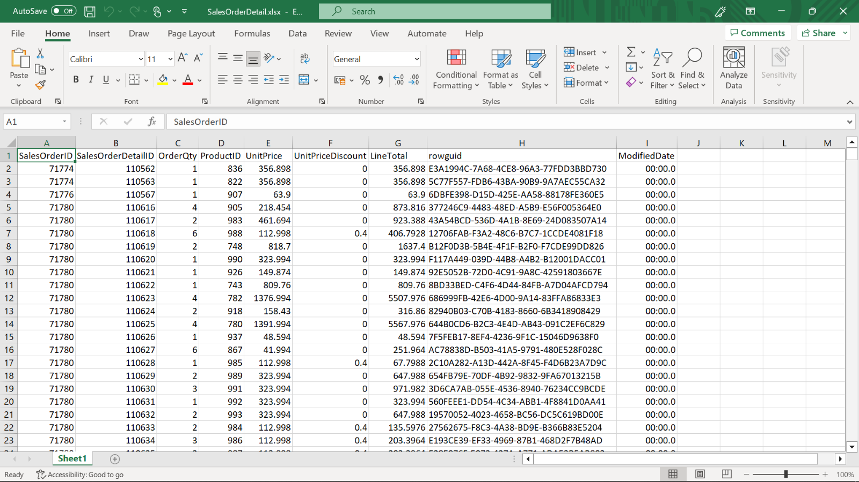

Before you can load your Excel file into Power BI, you must organize your data in a flat table. In a flat table, each column contains the same data type; for example, text, date, number, or currency. Your table should have a header row but no columns or rows that display totals. Next, format your data as a table. In Excel, on the **Home** tab, in the **Styles** group, select **Format as Table**.

1. Sign up for the Power BI Service Visit the Power BI website at [https://powerbi.microsoft.com](https://powerbi.microsoft.com/en-us/) and sign in using your organizational or school account.

**Step 2: Get the data to the Power BI service**

Once you have the resources ready, you can proceed to select data. The Power BI service connects to many data sources, including Excel files. You can use the **Get data** option to import or connect to an Excel workbook. From the File menu, select the location of your file.

The sales department at Adventure Works uploads the file every day to the company's OneDrive, so the location you should choose is OneDrive - Business. After uploading your workbook, it will be available in the Workbooks section of the workspace's navigation pane and in the workspace's content list. This action will add a dataset, and the report can be generated and published.

These are the steps to follow:

1. Launch Power BI.
2. Get data to import or connect.
3. Specify location of file.
4. Load to create a dataset.

These steps will guide you to get data ready for an automated refresh.

**Step 3: Configure a trigger**

To schedule updates for your dataset in Power BI Service, you'll need to set up a trigger.

1. Start by selecting the dataset you want to configure. You can do this by navigating to the **Datasets** tab of the left sidebar and clicking on the dataset you want to work with.
2. Once you've selected your dataset, choose a function to schedule a refresh. You'll have the option to schedule a regular refresh, or to set up an incremental refresh.
3. After selecting your function, you'll need to configure the parameters. This will depend on the function you've chosen, but common parameters include the refresh frequency and the start time for the refresh. Finally, apply the trigger to your dataset. You can do this by selecting **Apply** in the trigger configuration panel.

**Conclusion**

Learning how to configure triggers and connectors in Power BI can help you automate repetitive tasks, reduce the time spent on manual data entry, and improve the accuracy of your data. This exercise demonstrated how to set up a time-based trigger to automate the process of importing data from a local Excel file into a Power BI dataset. By following the steps provided, you can create a workflow that automatically updates the dataset at a specific time on schedule. This will allow you to focus on analyzing the data and providing valuable insights to your team at Adventure Works, without having to worry about the tedious and time-consuming task of manually importing and analyzing the data.

**Exemplar: Implementing triggers**

**Overview**

In the exercise Implementing Triggers, you learned how to set up a trigger and configure a connector to create a dataset that is automatically updated each night, saving you time and providing accurate data to meet your business needs.

In this reading, you will follow the steps to learn how Adio Quinn, a data analyst at Adventure Works, automated the daily task assigned to him. With Power BI, Adio could easily schedule data refreshes, allowing him to focus on delivering valuable insights to the management team and saving time in the process.

The following steps will create a trigger to import data from an Excel file every night at the same time. The report will be updated with the latest data.

**Step 1: Prepare the resources**

To begin, make sure you have all the required resources for this exemplar, including:

1. Access to Power BI. Sign into Power BI Service using your organizational or school account.
2. An Excel file. A sample dataset can be downloaded from the link to follow through the exercise.
3. A designated worksheet or table within the Excel file to serve as the data source.
4. The specific time for updating the data source.

To prepare your data for loading into Power BI, you need to format it as a table. To do this in Excel, go to the **Home** tab and click on the **Styles** group. From there, choose the **Format as Table** option and select a suitable style for your worksheet. Once you've completed this step, your Excel worksheet is now properly formatted and ready to be loaded into Power BI.

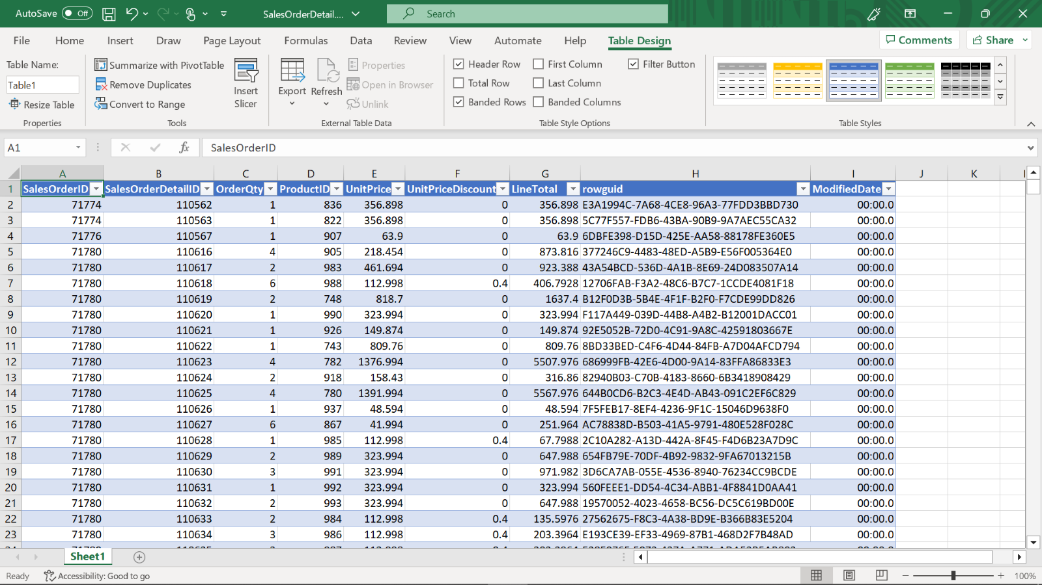

**Step 2: Get the data**

Before you begin preparing your data, let's review some important concepts, starting with the difference between a data source and a dataset. To help you understand these terms, let's use an analogy: think of a dataset in Power BI like a recipe in cooking, complete with instructions and ingredients. Your dataset contains all the data, metrics, and information that are displayed on your Power BI dashboard. Like a chef, you can obtain the ingredients (the data) from a store or garden (the data sources), which could be a database, web API, or CSV file, and use them to create a recipe (dataset) that produces insights and visualizations in Power BI.

Now, let's examine the difference between Power BI Desktop and service when it comes to uploading data. In Power BI Desktop, users can create three types of models to create datasets: Import, DirectQuery, and Composite. These models are based on how external data sources are integrated with imported data.

The Power BI service offers a streamlined experience for uploading files. You can upload files from your OneDrive for Business or SharePoint sites, or directly from your computer. If you choose OneDrive or SharePoint, Power BI creates a connection to the file. If you upload local files, a copy of the file is added to your workspace.

Let's now continue with the steps to **Get Data**:

1. Launch Power BI service. To import or connect to an Excel workbook, start by going to My Workspace in Power BI. From there, select the **Upload** button to upload your Excel file. Since the sales department at Adventure Works uploads the file every day to the company's OneDrive, select **OneDrive - Business** as the data source. To do this, select **Upload** in the top-left corner, then select **OneDrive - Business**. This will allow you to easily access the Excel file in Power BI.

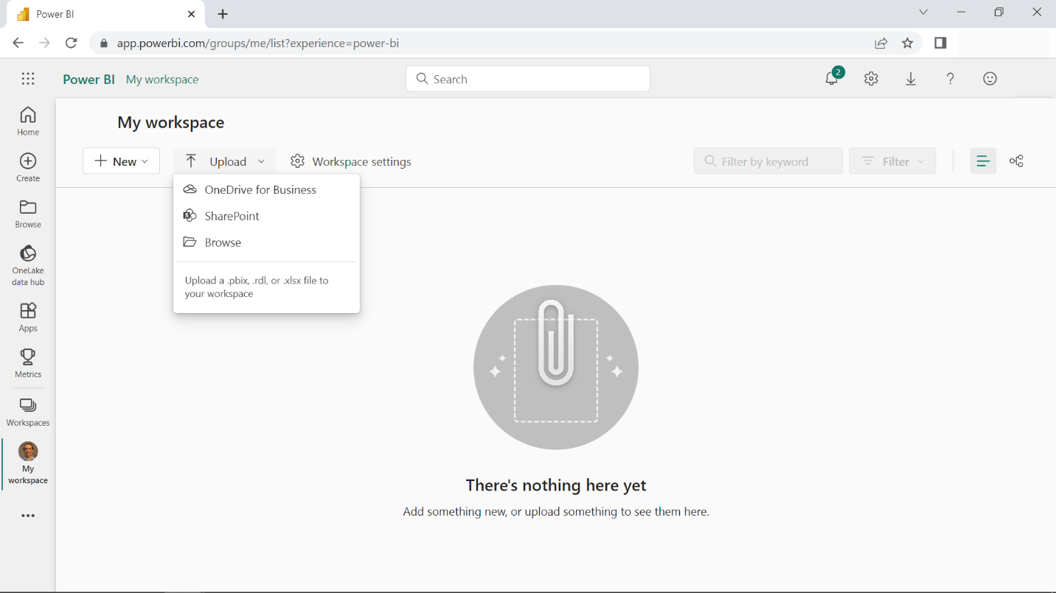

1. Select **Import** and browse to the location of your Excel file and select it.
2. Choose **Import** to upload your workbook. When you choose **Import**, Power BI imports any supported data in tables and any data model into a new Power BI dataset. When you upload an Excel file, the workbook item appears in Power BI just like it would in Excel Online, as shown in the following image.

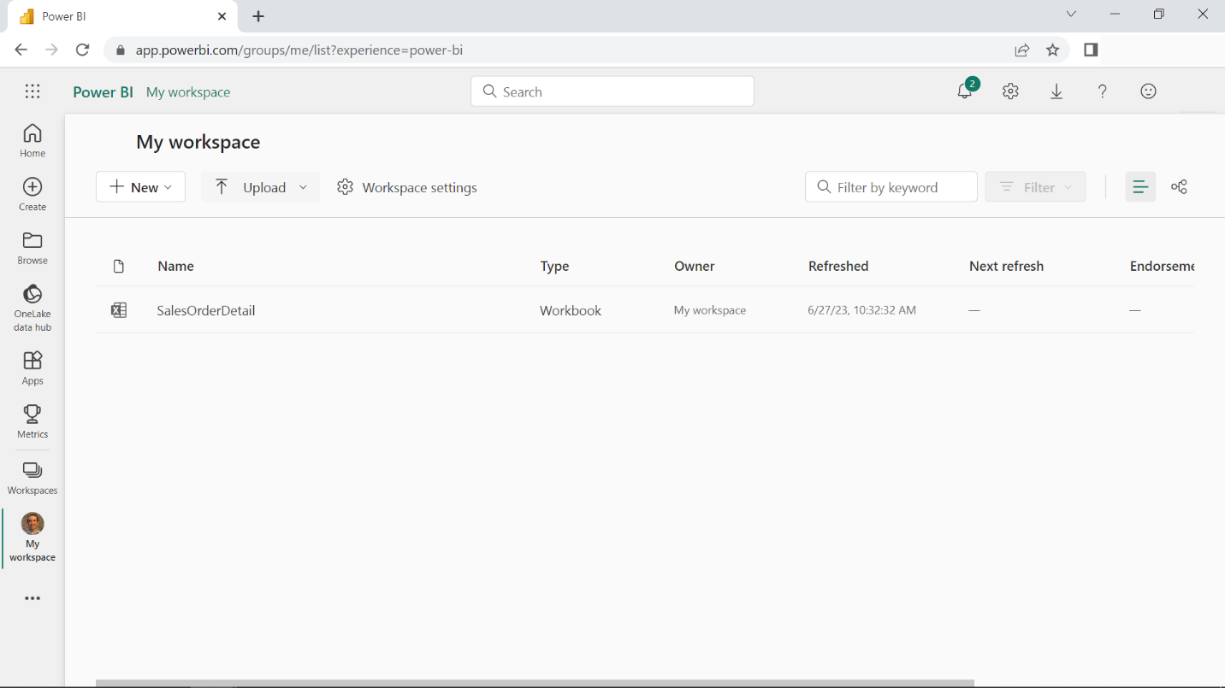

When you publish a Power BI Desktop file to Power BI service, you publish the data in the model to your Power BI workspace.

1. Open your Power BI Desktop application and load the dataset and report that you want to publish.
2. Choose **File** from the menu bar, then select **Publish** and select **Publish to Power BI**. Alternatively, you can select **Publish** from the **Home** ribbon.
3. If you are not already signed into Power BI, you will be prompted to do so. Enter your credentials to sign in.
4. Select the destination workspace where you want to publish your report. You can search your list of available workspaces by typing in the search box to filter your workspaces. Once you have found the workspace, select the **Select** button to publish.
5. Power BI will begin publishing your report to the selected workspace. Wait for the process to complete.
6. When publishing is complete, a dialog box will appear with a link to your report. You can then select the link to open the report in your Power BI site.

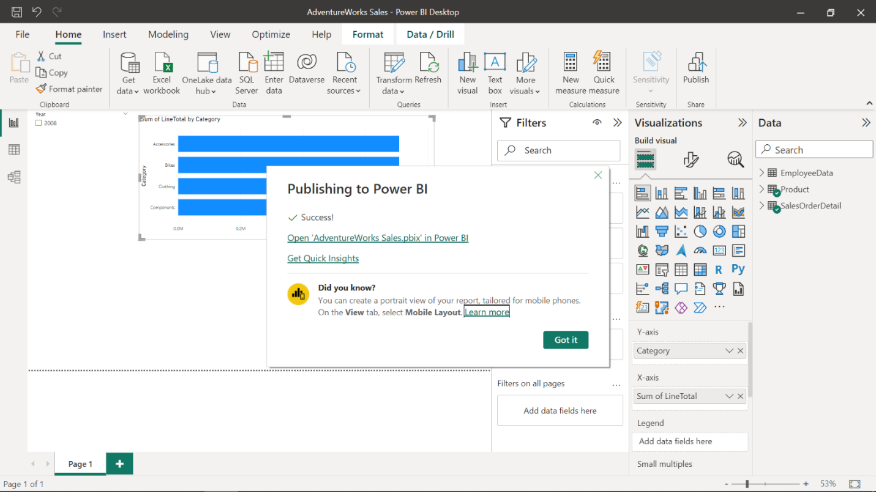

**Step 3: Configure trigger and incremental refresh**

The Scheduled refresh section is used to set the frequency and time slots for refreshing the dataset. While some data sources can be refreshed without a gateway configuration, others may require it. In the case of DirectQuery scenarios, if a dataset meets the criteria for performance optimization, the Refresh schedule will be relocated to the Optimize performance section. To configure the settings, turn on the Keep your data up to date slider.

Here are the steps to schedule a refresh for your dataset in Power BI:

1. Navigate to the **Data Hub** tab in Power BI and select the one you want to configure by clicking on it.
2. Choose a function to schedule a refresh, either a regular refresh or an incremental refresh.
3. Configure the parameters, such as refresh frequency and start time.
4. Apply the trigger by selecting **Apply**.

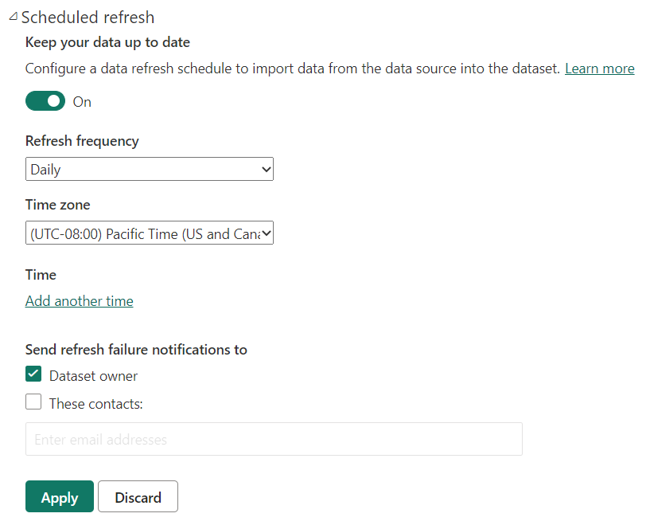

By following these steps, you'll be able to configure a trigger to schedule updates.

**Conclusion**

Learning how to configure triggers and connectors in Power BI can be a game-changer for automating repetitive tasks, reducing manual data entry, and improving data accuracy. By following the steps outlined in this exemplar, you can set up a trigger and connector to automatically import data from an Excel file into Power BI. This workflow will allow you to save time and effort by automatically updating your data at a specific time each night, giving you more time to focus on analyzing the data and providing valuable insights to your team at Adventure Works. With this knowledge, you can become more productive and efficient in your data analysis tasks and meet specific business requirements with fast and accurate data.